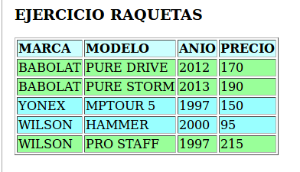
7.

<?xml version="1.0" encoding="UTF-8"?>
<xsl:stylesheet version="1.0" xmlns:xsl="http://www.w3.org/1999/XSL/Transform">
<xsl:template match="/">
<html>
<body>
<h3>EJERCICIO RAQUETAS</h3>
<table border="1">
<tr bgcolor="#CCFFFF">
<th style="text-align:left">MARCA</th>
<th style="text-align:left">MODELO</th>
<th style="text-align:left">ANIO</th>
<th style="text-align:left">PRECIO</th>
</tr>
<xsl:for-each select="TIENDA/RAQUETA">
<xsl:choose>
<xsl:when test="PRECIO>150">
<tr bgcolor='#99ff99'>
<td><xsl:value-of select="MARCA"/></td>
<td><xsl:value-of select="MODELO"/></td>
<td><xsl:value-of select="ANIO"/></td>
<td><xsl:value-of select="PRECIO"/></td>
</tr>
</xsl:when>
<xsl:otherwise>
<tr bgcolor='#99ffff'>
<td><xsl:value-of select="MARCA"/></td>
<td><xsl:value-of select="MODELO"/></td>
<td><xsl:value-of select="ANIO"/></td>
<td><xsl:value-of select="PRECIO"/></td>
</tr>
</xsl:otherwise>
</xsl:choose>
</xsl:for-each>
</table>
</body>
</html>
</xsl:template>
</xsl:stylesheet>

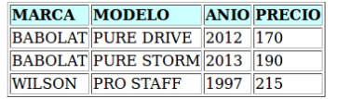
8.

<?xml version="1.0" encoding="UTF-8"?>
<xsl:stylesheet version="1.0" xmlns:xsl="http://www.w3.org/1999/XSL/Transform">
<xsl:template match="/">
<html>
<body>
<h3>EJERCICIO RAQUETAS</h3>
<table border="1">
<tr bgcolor="#CCFFFF">
<th style="text-align:left">MARCA</th>
<th style="text-align:left">MODELO</th>
<th style="text-align:left">ANIO</th>
<th style="text-align:left">PRECIO</th>
</tr>
<xsl:for-each select="TIENDA/RAQUETA[PRECIO>150]">
<tr>
<td><xsl:value-of select="MARCA"/></td>
<td><xsl:value-of select="MODELO"/></td>
<td><xsl:value-of select="ANIO"/></td>
<td><xsl:value-of select="PRECIO"/></td>
</tr>
</xsl:for-each>
</table>
</body>
</html>
</xsl:template>
</xsl:stylesheet>

9.
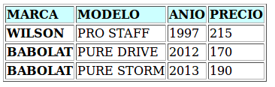

<?xml version="1.0" encoding="UTF-8"?>
<xsl:stylesheet version="1.0" xmlns:xsl="http://www.w3.org/1999/XSL/Transform">
<xsl:template match="/">
<html>
<body>
<h3>EJERCICIO RAQUETAS</h3>
<table border="1">
<tr bgcolor="#CCFFFF">
<th style="text-align:left">MARCA</th>
<th style="text-align:left">MODELO</th>
<th style="text-align:left">ANIO</th>
<th style="text-align:left">PRECIO</th>
</tr>
<xsl:for-each select="TIENDA/RAQUETA[PRECIO>150]">
<xsl:sort select="ANIO"/>
<tr>
<td style="font-weight:bold;"><xsl:value-of select="MARCA"/></td>
<td><xsl:value-of select="MODELO"/></td>
<td><xsl:value-of select="ANIO"/></td>
<td><xsl:value-of select="PRECIO"/></td>
</tr>
</xsl:for-each>
</table>
</body>
</html>
</xsl:template>
</xsl:stylesheet>

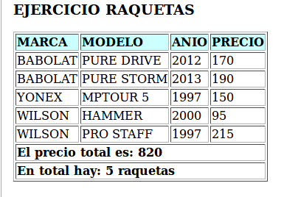
10.

<?xml version="1.0" encoding="UTF-8"?>
<xsl:stylesheet version="1.0" xmlns:xsl="http://www.w3.org/1999/XSL/Transform">
<xsl:template match="/">
<html>
<body>
<h3>EJERCICIO RAQUETAS</h3>
<table border="1">
<tr bgcolor="#CCFFFF">
<th style="text-align:left">MARCA</th>
<th style="text-align:left">MODELO</th>
<th style="text-align:left">ANIO</th>
<th style="text-align:left">PRECIO</th>
</tr>
<xsl:for-each select="TIENDA/RAQUETA">
<tr>
<td><xsl:value-of select="MARCA"/></td>
<td><xsl:value-of select="MODELO"/></td>
<td><xsl:value-of select="ANIO"/></td>
<td><xsl:value-of select="PRECIO"/></td>
</tr>
</xsl:for-each>
<tr>
<td colspan="4"><b>El precio total es: <xsl:value-of select="sum(TIENDA/RAQUETA/PRECIO)"/></b></td>
</tr>
<tr>
<td colspan="4"><b>En total hay: <xsl:value-of select="count(TIENDA/RAQUETA)"/> raquetas</b></td>
</tr>
</table>
</body>
</html>
</xsl:template>
</xsl:stylesheet>
11.
<?xml version="1.0" encoding="UTF-8"?>
<xsl:stylesheet version="1.0" xmlns:xsl="http://www.w3.org/1999/XSL/Transform">
<xsl:template match="/">
<html>
<body>
<h3>EJERCICIO RAQUETAS</h3>
<xsl:for-each select="TIENDA/RAQUETA">
<p><xsl:value-of select="MARCA"/><br/>
<xsl:value-of select="MODELO"/><br/>
<xsl:value-of select="ANIO"/><br/>
<xsl:value-of select="PRECIO"/></p><br/>
<hr></hr>
</xsl:for-each>
</body>
</html>
</xsl:template>
</xsl:stylesheet>

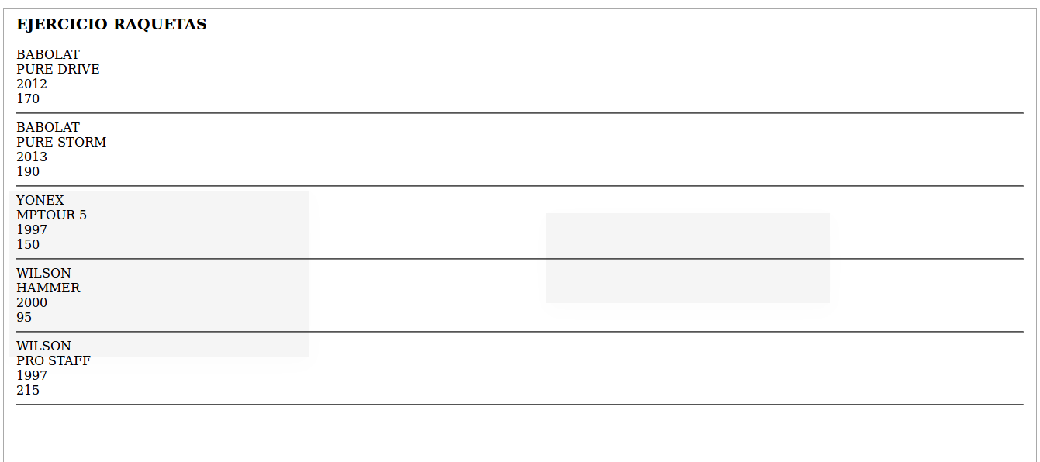
12.

<?xml version="1.0" encoding="UTF-8"?>
<xsl:stylesheet version="1.0" xmlns:xsl="http://www.w3.org/1999/XSL/Transform">
<xsl:template match="/">
<html>
<body>
<h3>EJERCICIO RAQUETAS</h3>
<xsl:for-each select="TIENDA/RAQUETA">
<ul><p><b>RAQUETA:</b></p>

<li><xsl:value-of select="MARCA"/></li>
<li><xsl:value-of select="MODELO"/></li>
<li><xsl:value-of select="ANIO"/></li>
<li><xsl:value-of select="PRECIO"/></li>
<hr></hr>
</ul>
</xsl:for-each>
</body>
</html>
</xsl:template>
</xsl:stylesheet>

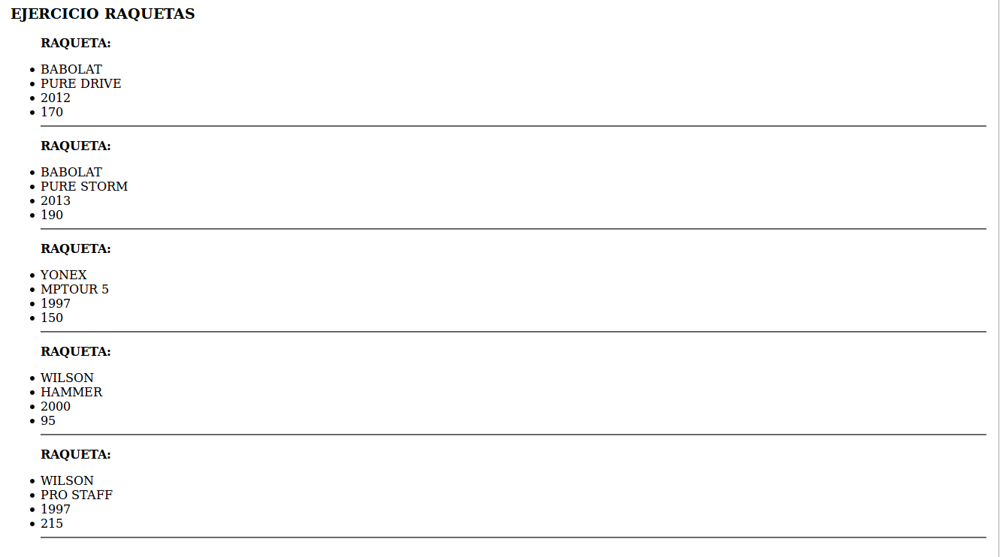
13.

<?xml version="1.0" encoding="UTF-8"?>
<xsl:stylesheet version="1.0" xmlns:xsl="http://www.w3.org/1999/XSL/Transform">
<xsl:template match="/">
<html>
<body>
<h3>EJERCICIO RAQUETAS</h3>
<xsl:for-each select="TIENDA/RAQUETA[MARCA='WILSON']">
<xsl:sort select="PRECIO" order="ascending"/>
<ul><b>RAQUETA:</b></ul>
<ol>
<li><xsl:value-of select="MARCA"/></li>
<li><xsl:value-of select="MODELO"/></li>
<li><xsl:value-of select="ANIO"/></li>
<li><xsl:value-of select="PRECIO"/></li>
<hr></hr>
</ol>
</xsl:for-each>
</body>
</html>
</xsl:template>
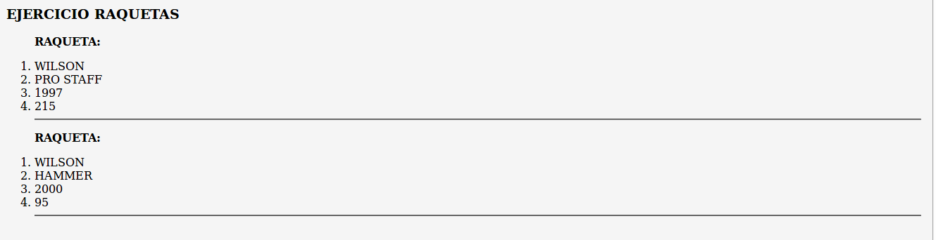
</xsl:stylesheet>

